SUMMATIVE memo



Answer the following question in the space provided below.

SESSION1.

INTERACT SUCCESSFULLY IN ORAL/SIGNED COMMUNICATION.
Learning Outcomes
- Contributions to group work are appropriate to the task and nature of the group, and promote effective communication and teamwork.
- Interviews successfully establish a relationship appropriate to the context, and provide a non-threatening opportunity for participants to share information.
- Participation in formal meetings is appropriate to the purpose and context of the meeting. Participation is consistent with meeting procedures and contributes to the achievement of meeting objectives.
- Participation in discussions, debates or negotiations is appropriate to the purpose and topic. Participation is consistent with the formality of procedures and contributes to meaningful interaction between participants.
- Responses to the ways others express themselves are sensitive to differing socio-cultural contexts.

Task 1
Outline the communication model

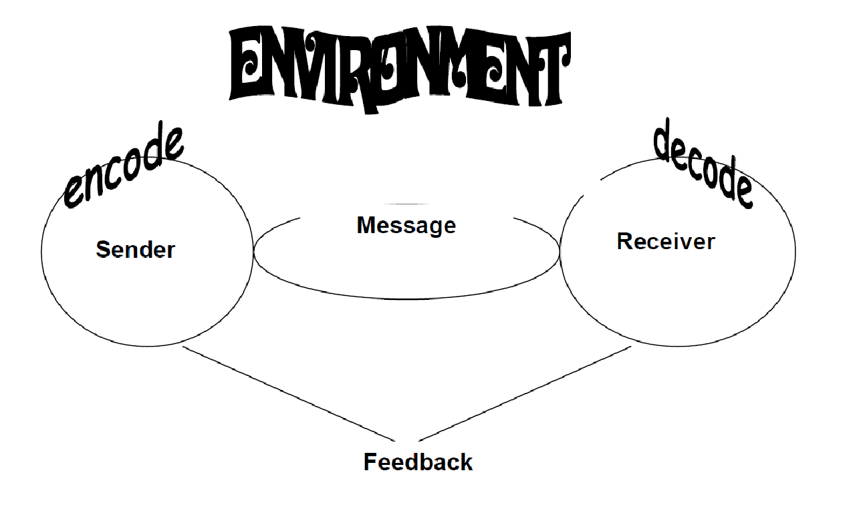
There are many factors which influence the communication process, all of which impact
each other in a variety of ways.

♦ Sender - the sender is the speaker/writer. A sender starts with an impulse he or
she wishes to express, and then must encode that idea into symbols (words) and
signs (facial expressions, tone of voice, etc.).

♦ Message - the message is the symbols and signs which are actually transmitted.
All messages are carried by a channel (face-to-face, over the phone, email, letter,
etc.).

♦ Receiver - the receiver is the listener/reader. The receiver must decode the
symbols and signs of the message, sent through the channel. Decoding involves
working through one's own perceptual filters, to arrive at thoughts which
approximate the sender's original intent.

♦ Feedback - feedback is the signs the receiver projects while the sender is sending
the message. Feedback allows the sender to know how his or her message is
being received, and whether the received message is the same as the intended
message.

♦ Environment - environment is the physical, social and emotional influences (often
referred to as 'noise'), the communication takes place in. Environments can place
expectations and/or constraints on communication.

SESSION 2.

USE STRATEGIES THAT CAPTURE AND RETAIN THE INTEREST OF AN AUDIENCE.
Learning Outcomes
- Key words/signs, pace and pause, stress, volume and intonation or sign size, pace, rhythm and non-manual features (NMFs) are used in appropriate ways to reinforce the message.
- Body language is appropriate to context and topic, and reinforces main ideas and points of view.
- Formal communications are planned in writing/signing, and plans are detailed, complete, and realistic with respect to time allocation and content.
- Visual aids are appropriate to topic and context, and enhance the presentation and the transfer of information and understanding.
- Techniques are used to maintain continuity and interaction.

Task 2
Explain the strategies that capture and retain the interest of an audience.

- Strategies that capture and retain the interest of an audience

The material of your presentation should be concise, to the point and tell an interesting story. In addition to the obvious things like content and visual aids, the following are just as important, as the audience will be subconsciously taking them in:

Your voice: How you say it is as important as what you say. Throughout your presentation, try to convey your enthusiasm and belief in the topic. The use of your voice establishes……

♦ rapport,
♦ maintains interest,
♦ emphasizes points and assists comprehension of the information by the audience.

This can be achieved by THE FOLLOWING:

♦ varying volume,
♦ pace,
♦ pitch,
♦ pause and
♦ tone.


Talk at a moderate pace if you have
excellent content. If your arguments are
weak, speak at a faster pace as this will
give people less chance for developing
counter arguments. Fast talkers are
regarded as more competent, truthful,
fluent, energetic, enthusiastic and
persuasive. By talking fast, you move
the attention from the content to
yourself. This being said, it is important
to match your pace to what needs to be
said - important instructions or
explanations need to be presented at a
moderate pace, whilst general
information could be presented at a faster pace.

Use a quiet, reasonable tone for the content, but still show some energy and interest. Pauses of two seconds before key points are recommended to create interest and attention in what follows. Pauses after key points allow people to reflect on what was said.

Body language: Your body movements express what your attitudes and thoughts really
are. Your movements attract attention and give the audience something to follow. The following tips can assist you.

♦ If you have been standing still or behind a podium, move to the right or left or toward the audience.
♦ Use gestures to emphasize a point.
♦ Facial expressions also help to convey a message.
♦ Maintain eye contact and don't forget to smile!
Different body posture
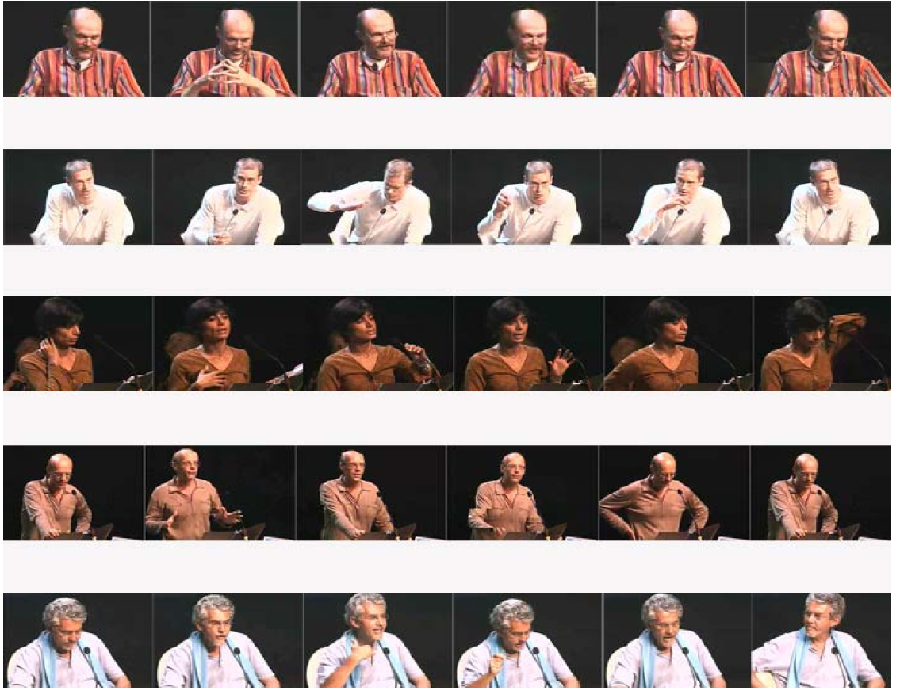

Appearance: First impressions influence the audience's attitudes to you. Dress appropriately for the occasion and to show you respect the audience
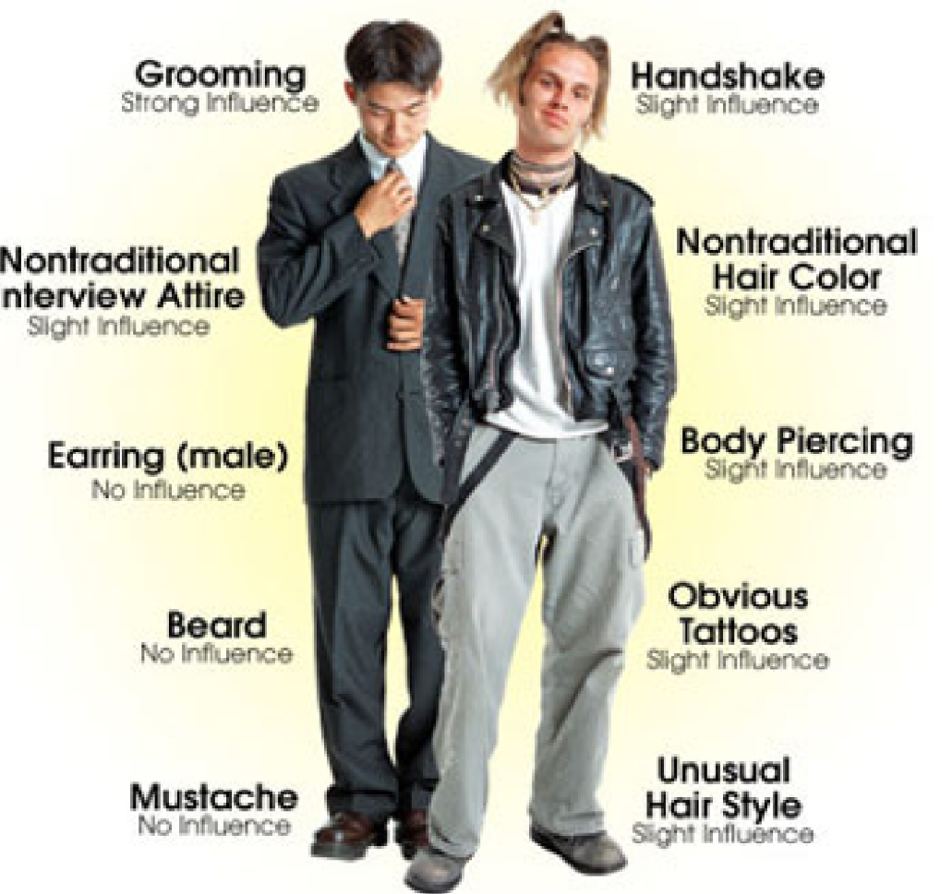
As with most personal skills, oral communication cannot be taught. So as always, practice is essential, both to improve your skills generally and also to make the best of each individual or group presentation you make.

- Planning

Initial Planning: This is where you begin to tailor the talk to the situation, and for that reason, this stage is very important for a successful presentation. Begin this stage early, the more lead time you allow yourself, the more time you will have to think up potential approaches to the topic and the more interesting and substantial your presentation will be.
Before you begin preparing the presentation, you'll need to determine:

The type of talk you'll be expected to give:
♦ Will this be an informal chat, a seminar discussion, or a more formal presentation?
♦ Different talks have different purposes.
The composition of the audience
♦ Will you be speaking to a general audience or specialists?
♦ How many people are expected to attend?
The time allotted for the talk
♦ The longer the talk, the more freedom you will have to explore the topic.
♦ A short talk needs to be very clear and to address the topic directly.
♦ Let your audience know that you regard their time as precious and have no intention
of wasting it.
♦ Keep to your allotted time - do not extend it and do not keep rambling on just to fill
your time slot. "If you haven't struck oil in five minutes - stop boring!"

Expectations for information content
♦ What is the purpose of your talk? Clarify the expectations beforehand and plan to
address them during the presentation.
♦ Will you be presenting novel concepts to this audience, or building upon their prior
knowledge? Either way, make sure you cover the basics clearly, and early in the talk, to avoid confusing the audience.
3. Visual aids
Visual aids enhance the presentation, the transfer of information and the understanding thereof. They do, however, have to be appropriate to the topic and the context.

Cue cards: These are a visual aid for you, the presenter. The notes must be written boldly, in print not script, and must list key words only. The cards must fit in the palm of your hand.
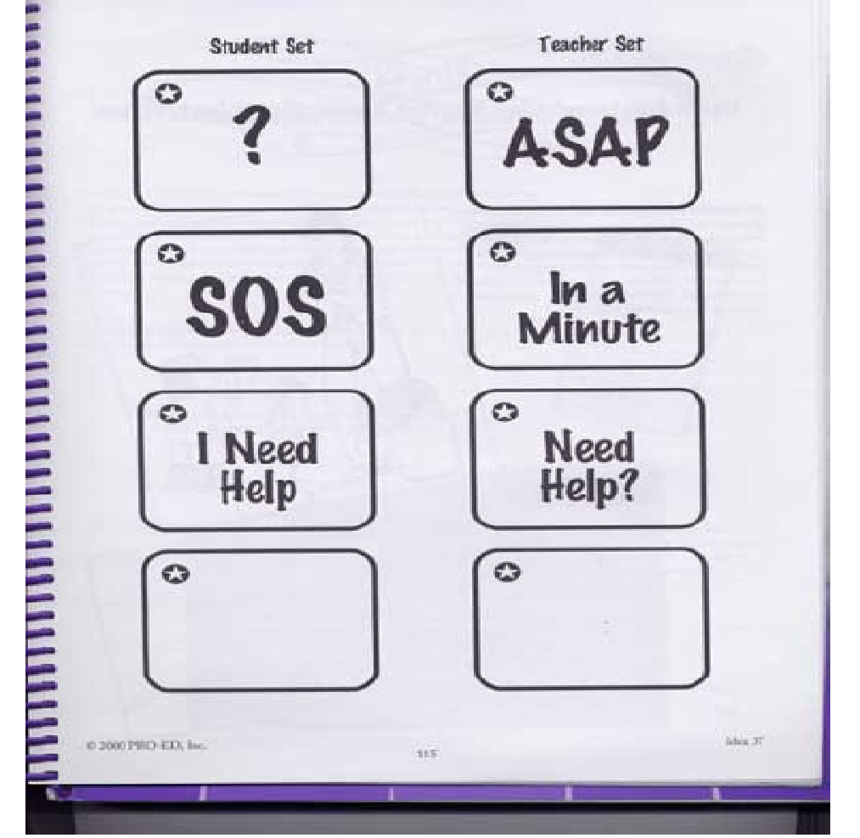

Handouts: Do not hand out material to read when you begin thepresentation:
♦ It may cause the listeners to get
out of step with the speaker,

unless the handout contains
information that needs to be
referred to during the
presentation.
The purpose of this material is to:
♦ Convey information more
clearly and concisely than can
be transferred orally.

Do not include anything that is unnecessary. All tables, charts, graphs, maps and diagrams should be made simple and as clear as possible. Too much detail will make them difficult to understand.

It is a good idea to include your references on a handout, so that people can follow up on them later. A paper record (handout) tells your audience that you are serious, responsible, exact and credible. It gives the audience something they can read, take away, make copies of and refer to at a later stage.

Multi-media and visual aids: PowerPoint presentations, transparencies, or flip charts can help people follow the talk. This is especially important to show organization, present lists, highlight illustrations and exhibits, and summarize data. People think in pictures. Say Nike and people "see" the swoosh. Say Energizer and people "see" the bunny. Say (your name hear) and what do people see? That is why logos and other graphical elements are so important. Tapping into the visualization part of the brain is probably the most powerful way to communicate with anyone. When putting together a PowerPoint presentation, keep the following in mind:

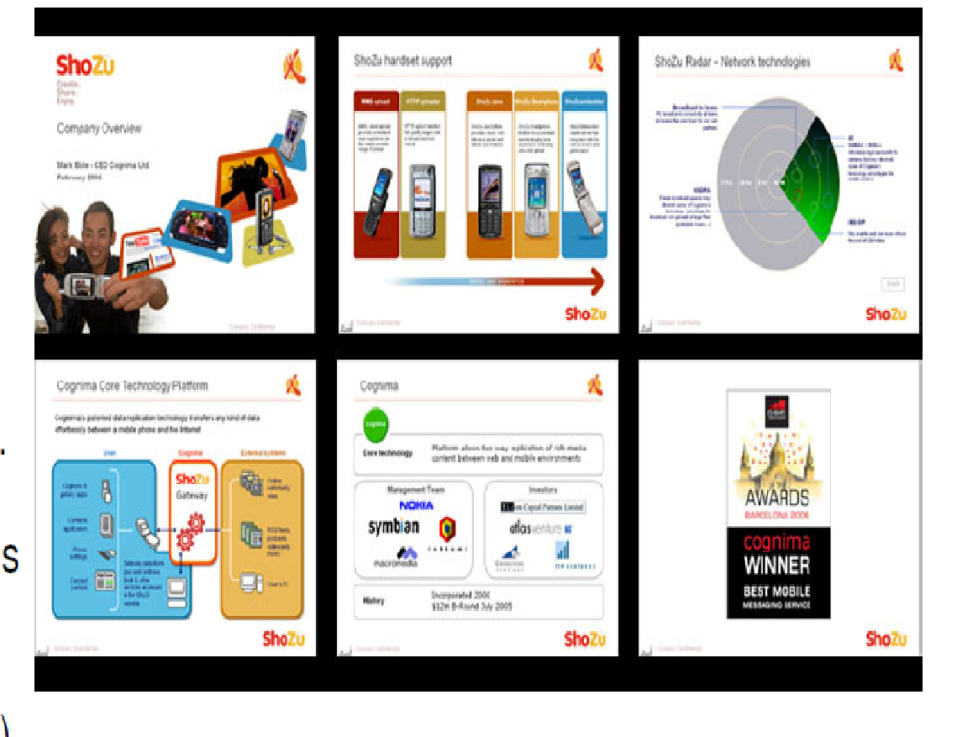
♦ key words on bullet points -
this helps to retain audience
attention and gives you a
reason for being there
(anyone can read, so you do
not want to read to them).
♦ omit anything that is not vital. PowerPoint often leads people to include irrelevant things (only if you have nothing
important to say, should you
use lots of bells and whistles).

♦ only use colour when the colour has a meaning. Keep in mind that some people are colour-blind and others may make black and white copies of the slides, in which case the colour would be meaningless

SESSION 3.

IDENTIFY AND RESPOND TO MANIPULATIVE USE OF LANGUAGE.
Learning Outcomes
- Facts and opinions are identified and distinguished.
- Omission of necessary information is noted and addressed.
- The implications of how the choice of language structures and features, specifically tone, register, style and point of view affect audience interpretations of spoken/signed texts are explained
- Distortion of a contributor's position on a given issue is explored with specific reference to what has been selected and omitted.

Task 3

Identify the appropriate form of communication in each of the situations below
Situation | Form of communication
You have to take time off work. | verbal
Invite someone to the movies | verbal
Invite your boss to dinner | verbal
Cancel an insurance policy | written
Request a meeting with your superior | Written or verbal
Send greetings to a friend | written
Apply for a loan | Written

Task 4
John and a few of his friends work for a huge multi-national company and are unhappy that the staff kitchen only provides tea and not coffee.
They decide to set up a meeting with the Financial Director and CEO, saying that they have a grievance and demand to be heard.

Let’s say they had a legitimate complaint that needed to be addressed by these two individuals. What course of action should they take in order for their communication to succeed?

Learner own answer

